NCLC EXAM TABLETS FACTORY RESET
CP20 Android Tablets
When something locks up or doesn’t work, it’s just as easy to do a factory reset as it is to troubleshoot (most of the time). We’ve seen this happen when the student goes to the login page from the browser and for some reason it says that the account is deactivated and wont’ let them enter a username and password.
You should check this in advance of the testing to ensure that it doesn’t happen. Just open the browser to see that it goes to the homepage where they login for the test. It should give them a form to enter username and password. If instead it says something about account deactivated and you can’t refresh it to get the login screen, just reset it.
Here are the steps:
Settings (from home screen) / Reset Options / scroll down to System / Erase all data (factory reset)/Erase all data (at lower right) /Erase all data (at lower right) /
That will allow you to start from the beginning and it will add all the program icons back to the home screen. If you’re on time constraints to get it working for the exams, just leave those programs there but go back and connect the wifi to your router, and then create the homepage for that chrome browser as https://lasertraining.learn.trakstar.com. That way it can be used to take an exam right away.
If you do a reset, then you should go back and reset the device as per the initial setup and configuration instructions for a new device. Refer to Proctor’s library under “Contact” on https://LaserCertification.org.
Screenshots for the steps listed above for the reset are:
Settings / Reset Options
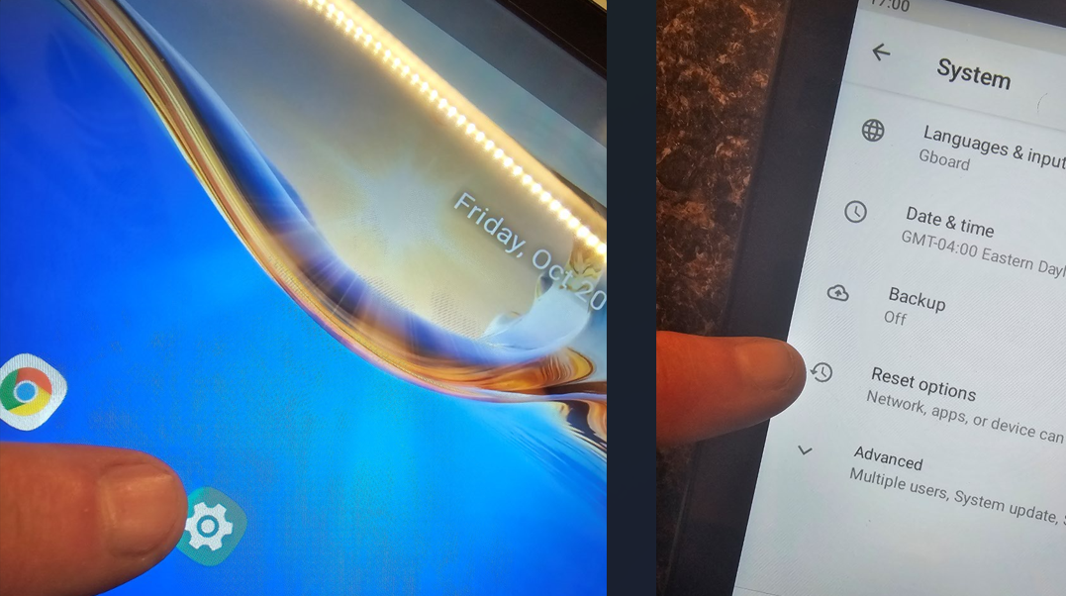
System / Erase all data
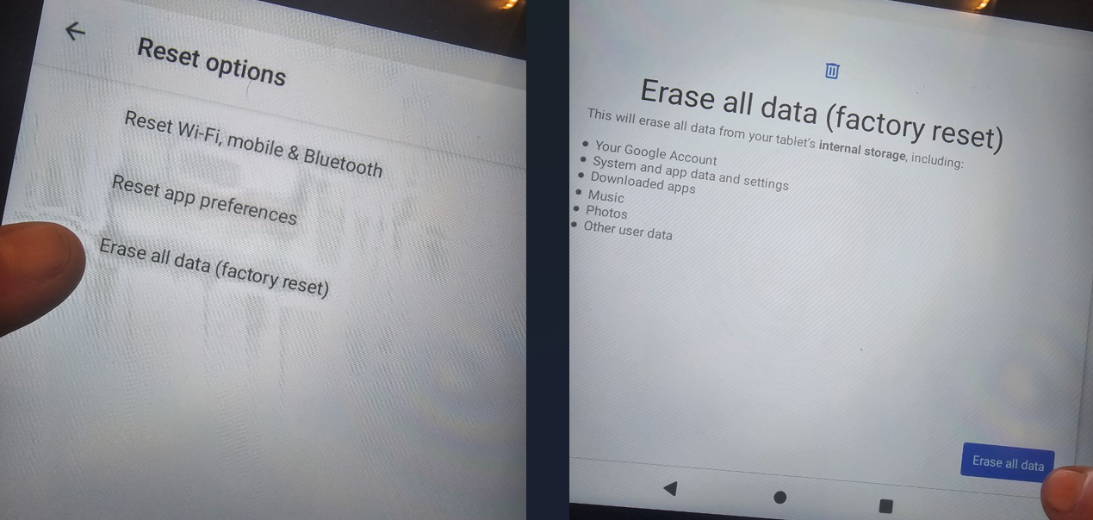
Erase all data /
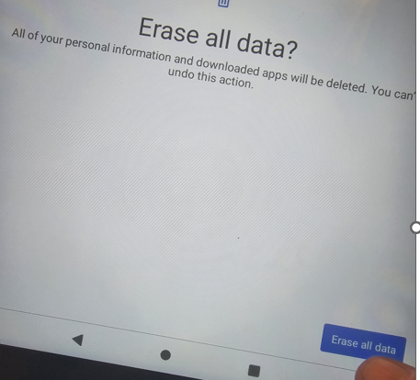
Now you’re back to factory new settings.
If you are using your own dedicated devices (not for any other use other than testing) instead of these NCLC Tablets, then you’ll need to do your own resets.

